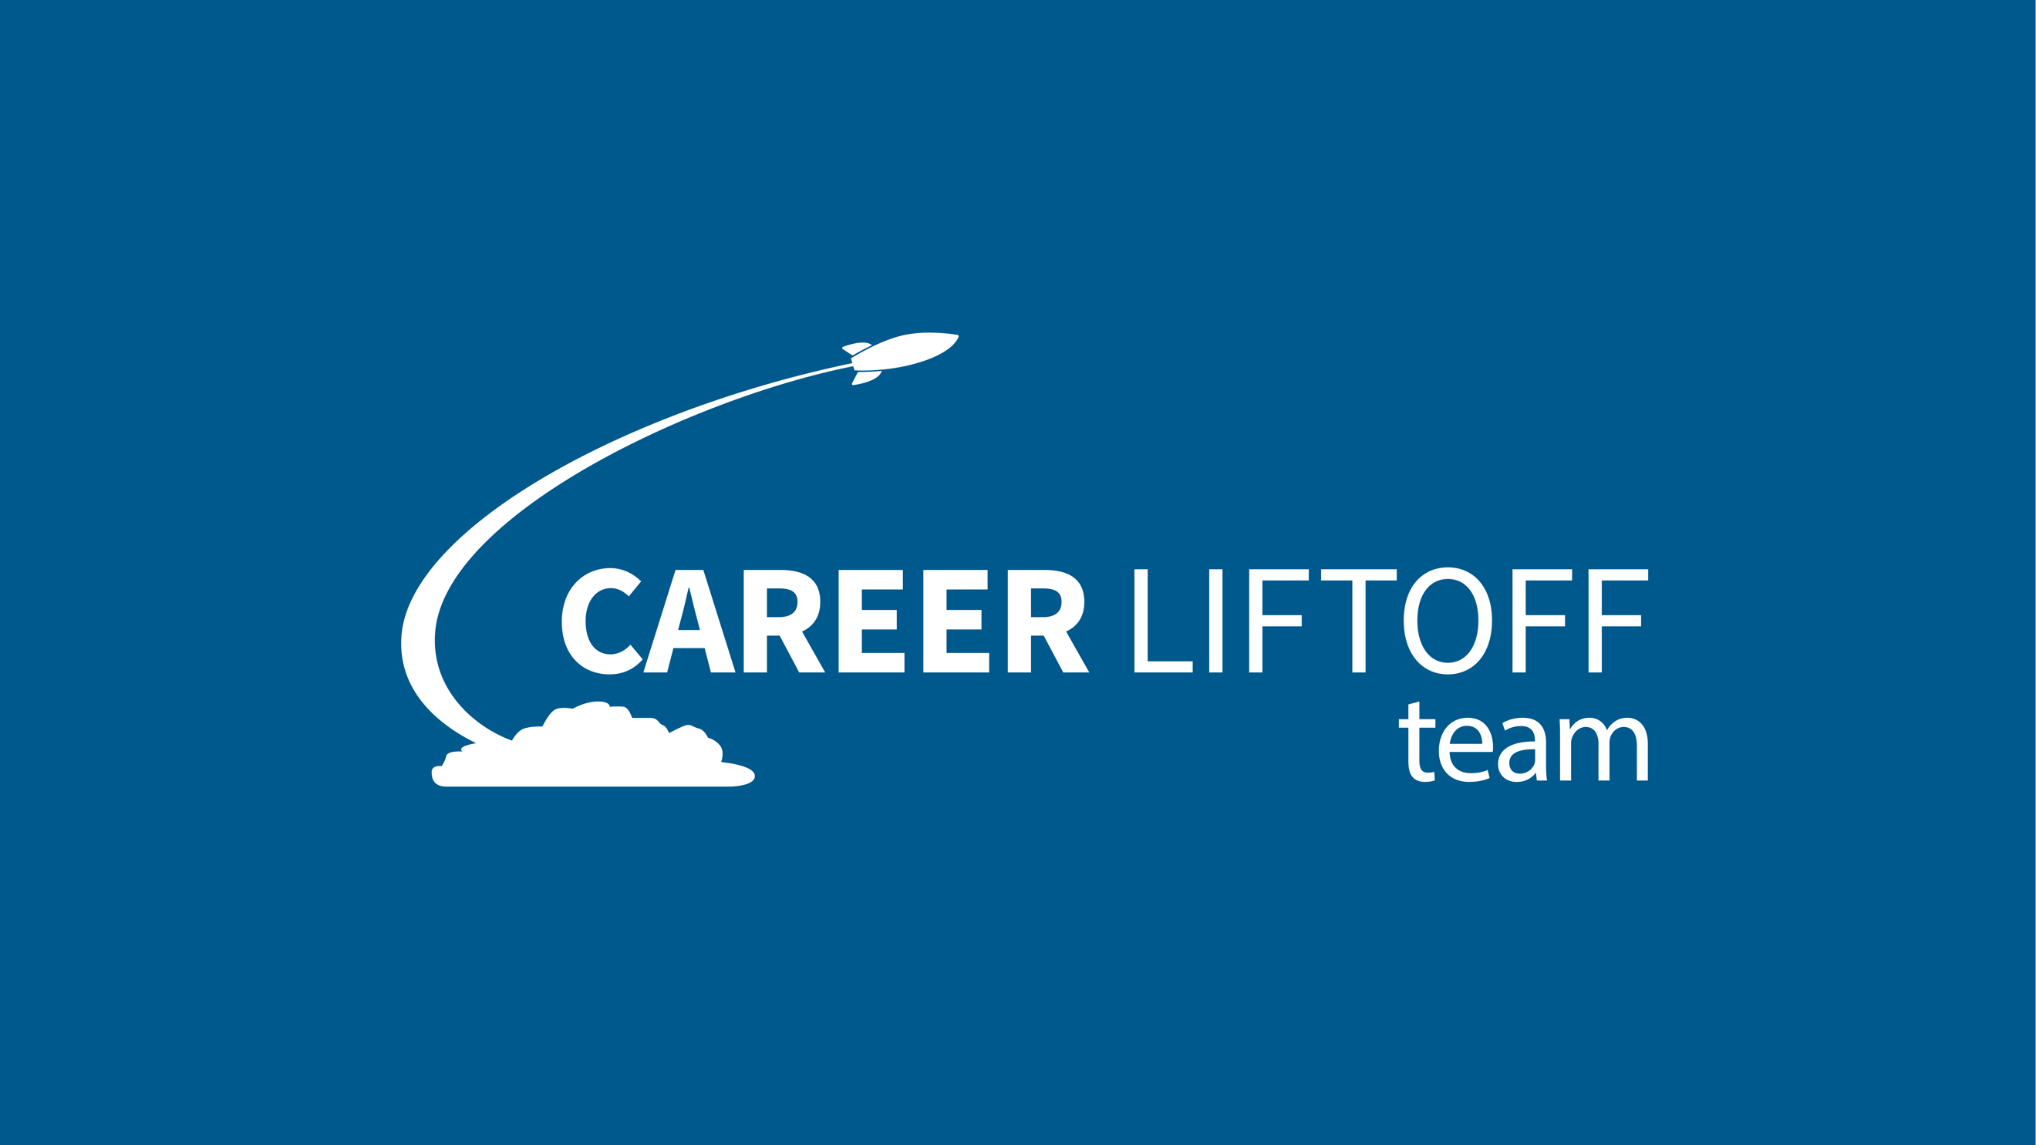

Join a group of supportive job seekers just like you!
You asked for small group sessions, and we’ve heard you.
Welcome to the Career Liftoff Team, a group of job seekers who meet by Zoom each week to share the struggles, the activities, the secrets, the frustrations, and yes, the successes of their job search.
The group will be led and moderated by Catherine Jewell, The Career Passion® Coach. She is an expert in job seeking who has a special knack for encouraging job seekers. Each week, we’ll be co-creating new, innovative strategies to keep you motivated and at the top of your game. Her clients report a huge increase in confidence and effectiveness, and that is also available to you. With weekly coaching, her clients consistently find jobs faster – 55, 40, 30, or even 21 days into their search!
The Career Liftoff Team will start on the first Wednesday of each month, and it’s limited to just 5 participants. Your investment of $200 covers the 4 weekly sessions, a fraction of what just one hour would cost for one-on-one career coaching.
Details
First through Fourth Wednesday of each month
5 – 6 pm CST
Investment: $100*
Max 10 participants per team

Each one-hour Zoom meeting will include:

- Celebrating successes of the week
- Check-ins with each member, reporting on job-seeking activities
- A short lesson, providing new tools and strategies for your search
- Break-out rooms for peer-to-peer coaching and goal setting
- Sharing trends, issues, and problems you are experiencing
- One-on-one time to answer questions and coach you on ANY job-seeking issue

Weekly topics:

Week 1: The Proactive Job Search—what metrics matter and how to maintain momentum
Week 2: Empowered Networking—a formula for better conversations that creat job leads
Week 3: Polishing your “Tell Me About Yourself”—speaking into the job and company culture
Week 4: STAR Stories—storytelling that defines your talents and skills

These are just some of the benefits you’ll receive:

- Networking with like-minded job seekers
- Learning from others’ experiences, mistakes, and successes
- Inside information about interviewing at specific companies
- New strategies when you feel discouraged
- The fun of sharing a journey together!
- A SWAT (Search With A Team) you can continue with after the 4 weeks!

Team Leader: Catherine Jewell, The Career Passion® Coach

Catherine wants everyone to grow and prosper in their career. She is The Career Passion® Coach, a trainer, and a professional speaker. She works with mid-life job seekers who want to up-level their job position, change careers, or just find a new job. Through her workshops and coaching, she has helped more than 3,000 business professionals create and find new, more satisfying work.

A career changer herself, Catherine believes talent and skills are always transferable to a new challenging position. She holds a degree in Broadcast Journalism. Her career includes stints with ABC Broadcasting, several magazines, and an advertising agency. She has also worked as the marketing director for a national CPA firm. Catherine successfully made a switch to the training profession through networking and informal training. She boot-strapped her way into becoming Training Director for a division of The Principal Financial Group. She is the author of three career books, including the new ebook Empowered Networking. You can find more information at CareerPassionCoach.com.

If wishing to join the next team, please contact Launch Pad Executive Director Shannon Mantrom at smantrom@launchpadjobclub.org

*Payment can be divided into two $50 payments:
the first payment before the 1st team meeting; the second payment before the 3rd team meeting.
Contact Shannon for this consideration.

